**Literature Survey**

**Original Research Paper:**

Link: [Human Activity Recognition on Smartphones for Mobile Context Awareness](https://core.ac.uk/download/pdf/41773853.pdf)

For the given research, the researchers are using Activity-Based Computing to capture the state of the user and its environment by using heterogeneous sensors. When these sensors are attached to the subject’s body, they permit continuous monitoring of numerous physiological signals.

This has appealing use in healthcare applications, e.g. in daily activity monitoring for elderly people. Some recent applications can be tracked in the form of smart watches for example where it traces the number of steps walked.

In this paper, they have used One-vs-All approach for the classification.

**Related Research Papers:**

Link: [A Smartphone-Based Adaptive Recognition and Real-Time Monitoring System for Human Activities](https://ieeexplore.ieee.org/stamp/stamp.jsp?tp=&arnumber=9078047)

In this paper, the writers have proposed a smartphone-based adaptive recognition and real-time monitoring system for human activities.

The researchers were aiming for online learning algorithm. It was capable of updating the classifier in a dynamic environment, i.e., which means if any new activity is found, the HC classifier will be updated automatically to include the new class. It is an unsupervised online learning algorithm that does not need to get the true labels.

Link: [A Public Domain Dataset for Real-Life Human Activity Recognition Using Smartphone Sensors](https://www.mdpi.com/1424-8220/20/8/2200)

In this paper, the main aim of the researchers is to create a more real world dataset and use it for Human Activity Recognition (HAR). One such key difference can be seen in the form of using a movable sensor for data collection. In earlier experiment setups, sensors had to be fixed in one position while collecting data.

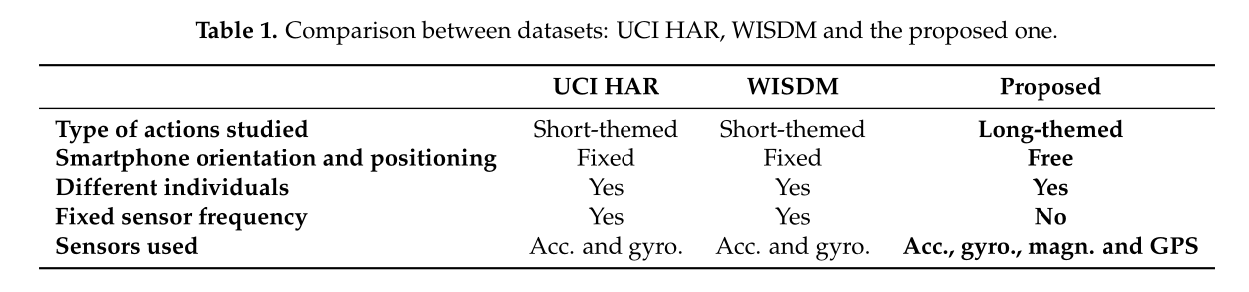Here also, they have used One-vs-All approach.

**DATASET**

**Experiment Setup:** [Activity Recognition Experiment Using Smartphone Sensors](https://www.youtube.com/watch?v=XOEN9W05_4A)

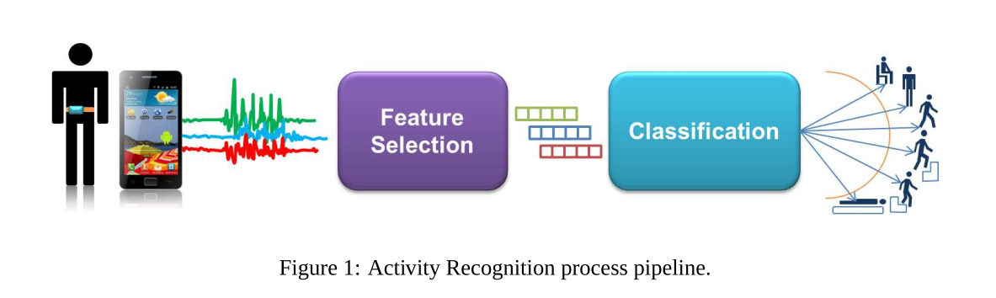

**Input sources** – Smartphone sensors (in the case of experiment, gyroscope and accelerometer has been used)

The recognition process starts with the acquisition of the sensor signals, which

are subsequently pre-processed by applying noise filters and then sampled in fixed-width sliding windows of 2.56 sec and 50% overlap. From each window, a vector of 17 features is obtained by calculating variables from the accelerometer signals in the time and frequency domain (e.g. mean, standard deviation, signal magnitude area, entropy, signal-pair correlation, etc.). Fast Fourier Transform is used for finding the signal frequency components. Finally, these patterns are used as input for the recognition of the activities.

Number of features – 561

Data has been collected along all three X, Y, Z axes.

Number of patterns in train set – 7352 (70%)

Number of patterns in test set – 2947 (30%)

Number of output class – 6

1 WALKING

2 WALKING_UPSTAIRS

3 WALKING_DOWNSTAIRS

4 SITTING

5 STANDING

6 LAYING

**Representation of dataset:**

Dataset has been provided in three different files. These are:

i. subject_train.txt – Representing the volunteer number in the experiment

ii. X_train.txt – Space separated text file with patterns with 561 features

iii. Y_train.txt – Representing the class of the action person is performing

Given dataset has already been normalized in the range of [-1, 1].